Normalization
Process of restructuring a relational database in accordance with a series of normal forms in order to reduce data redundancy.
Rdeundancy is nothing but repetition/duplication
Most commonly used normal form is 3NF
- First Normal Form (1NF)
- Second Normal Form (2NF)
- Third Normal Form (3NF)
- Boyce-Codd Normal Form (BCNF) or Fourth Normal Form (4NF)
- Fifth Normal Form (5NF)
- Sixth Normal Form(6NF)
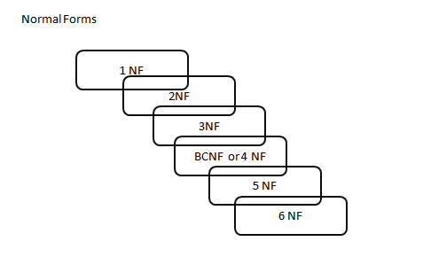

First Normal Form (1NF) : A relation is said to be in first normal form if and only if a primary key is defined for the relation and all non-key attributes are dependent on key attributes. The attributes that are part of primary key are called as key attributes and all remaining attributes are called as non-key attributes. As an example observes the following relation that contains information regarding various projects and employees working in those projects.
PID | Proj. Name | EmpID | Ename | Job | Charge/Hour | Hours Worked
P101 | College Maintenance | 1001 | A | Sr. Programmer | 500 | 3
P101 | College Maintenance | 1007 | K | DBA | 750 | 2
P102 | Hospital Maintenance | 1001 | A | Sr. Programmer | 500 | 5
P102 | Hospital Maintenance | 1005 | S | DBA | 750 | 3
In order to convert the above table to 1NF, a primary key must be defined for the table and all non-key attributes must be dependent on key attributes. In this table, it is not possible to define primary key on a single column as every column can contain duplicate values. Hence we can define primary key on the combination of PID and EMPID Columns. Now by giving the values of PID and EMPID columns, we can retrieve the values of every other column in the table. Hence the table is said to be in 1NF. Finally Table is represented as follows after defining a primary key on PID and EMPID columns.
(PID, EMPID) Pname, Ename, Job, Charge/Hour, Hours Worked
Using key attribute combination, we should be able to identify records uniquely (No duplicate records)
Second Normal Form (2NF): A relation is said to be in 2NF if and only if the relation is in first normal form and no partial dependencies exist in the relation. If primary key is defined on more than one attribute and a non-key attribute is completely dependent on only one key attribute then that dependency is called as partial dependency. The above table after conversion to 1NF, contains PID and EMPID combination as primary key. But to get PNAME there is no need to provide EMPID. Hence PNAME is partially dependent on key attributes. In the same way to get ENAME, JOB, CHARGE/HOUR and HOURS WORKED, there is no need to provide PID. Hence these attributes are also partially dependent on key attributes. The above relation is not in 2NF.
(PID, EMPID) Pname, Ename, Job, Charge/Hour, Hours Worked
To convert the above relation to 2NF, we have to divide the table as follows.
1. (PID) Pname
2. (EMPID) Ename, Job, Charge/Hour
3. (PID, EMPID) Hours Worked
Now all three relations are said to be in 2NF, as they doesn’t contain partial dependencies.
2NF ➔ 1NF + NO PARTIAL DEPENDENCIES (primary key is defined on more than one attribute and non-key attribute is completely dependent on only one key attribute)

Third Normal Form (3NF) : A relation is said to be in 3NF, if and only if the relation is in 2NF and no transient dependencies exist in the relation. If a non-key attribute depends on another non-key attribute, then that dependency is called as transient dependency. In the above three tables that obtained by converting the table of 1NF to 2NF, second table contains CHARGE/HOUR column, which was actually dependent on JOB but not on EMPID. To convert this table, which was not in 3NF to 3NF, we have to divide the table as follows.
1. (PID) Pname
2. (EMPID) Ename, Job
3. (JOB) Charge/Hour
4. (PID, EMPID) Hours Worked
Now all the four tables are in 3NF, as they don’t contain transient dependencies.
As the normalization steps proceed to higher normal forms, no. of tables in the database will increase. When no. of tables increases, the database performance will be reduced as we have to combine the data from more than one table. This is the reason why database designers are restricted to 3NF.
3NF ➔ 2NF + NO TRANSIENT DEPENDENCIES (non-key attribute depends on another non-key attribute)
In simple terms: If we increase normal form then number of tables will also increase
If we increase normal form then we will have more number of smaller tables

More examples on Normalization
Orders
PK PK | orderid productid
Orderdate
qty customerid
companyname
Data model after applying 1NF
Orders
PK | orderid
 | orderdate customerid companyname

 | OrderDetails
 | PK,FK1 PK | orderid productid
 |  | qty

Data model after applying 2NF
Customers
PK | customerid
 | companyname

 | Orders
 | PK | orderid
 | FK1 | orderdate customerid

 | OrderDetails
 | PK,FK1 PK | orderid productid
 |  | qty

Data model after applying 3NF

One thing to observe here if the tables are normalized we will have more number of small tables
Scenario1: perform DML operations on normalized tables
If we have to insert/update/delete data from those tables they will be faster
Scenario2: Perform Data retrieval on normalized tables (Analyze/read data)
We will have to join data from multiple smaller tables and select statements will be slow
Online Transactional processing (OLTP)
Focus of an OLTP system is data entry and not reporting. Transactions mainly insert, update and delete data. The relational model is targeted primarily at OLTP systems, where a normalized model provides both good performance for data entry and data consistency.
In a normalized environment, each table represents a single entity and keeps redundancy to a minimum. When you need to modify a fact, you need to modify it in only one place. This results in optimized performance for data modifications and little chance for error.
However, an OLTP environment is not suitable for reporting purposes because a normalized model usually involves many tables (one for each entity) with complex relationships. Even simple reports require joining many tables, resulting in complex and poorly performing queries.

Operational Database
Loan
Credit
Card
Trust
Savings

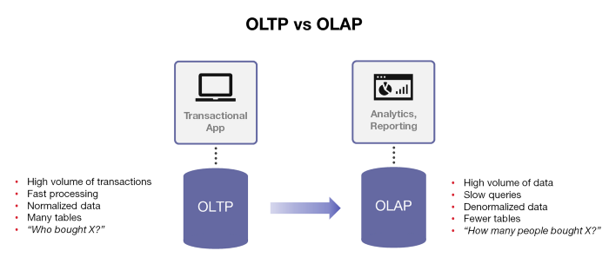
De normalization is used to combine multiple table data into one so that it can be queried quickly. De Normalized=> Lesser number of tables
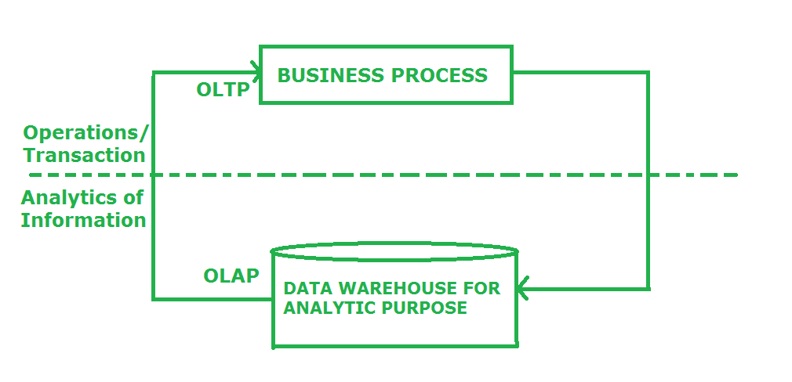
OLTP Systems are used to “run” a business (requires mostly current data)
Data Warehouse helps to “optimize” the business (requires historical data)
Data Warehouse Concepts
Data Warehouse:
It is a repository of an organization's data, designed to facilitate reporting and analysis with large amount of data.
- A DWH is a historical database because the database contains many years of historical business data for Decision making purpose.
- A DWH system is designed to read the business data for business analysis processing but not for Transactional processing. Hence it is called as a Read only database.
- A DWH is designed to take the decision. Hence it is also known as DSS (Decision Supportive System).
Single, complete and consistent store of data obtained from different sources made available to use in a business context
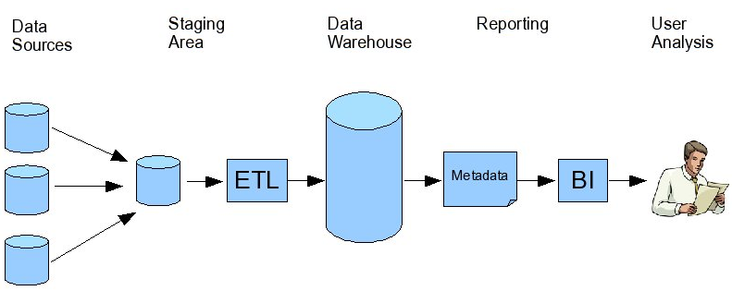
Transforming data into information
A data warehouse (DW) is an environment designed for data retrieval and reporting purposes. When it serves an entire organization, such an environment is called a data warehouse. The model has intentional redundancy, fewer tables, and simpler relationships, ultimately resulting in simpler and more efficient queries as compared to an OLTP environment.
ETL => Extract from source, Transform the data and load it into Target database
ETL Tools: Informatica, Datastage, SSIS, Talend, Cloud ETL Tools (ADF, Matillion, Informatica cloud IICS), dbt (transformation tool)

- The fathers of DWH are W.H. Inmon & Ralph Kimball. W.H.Inmon defined the DWH as
Time Variant, Non Volatile, Integrated and Subject Oriented.
- Time Variant: In order to discover trends in business, analysts need large amounts of data. This is very much in contrast to online transaction processing (OLTP) systems, where performance requirements demand that historical data be moved to an archive. A data warehouse's focus on change over time is what is meant by the term time variant.
A business user can analyze the business data in the warehouse to the different time periods like Year, Quarter, Month, and Weeks etc.
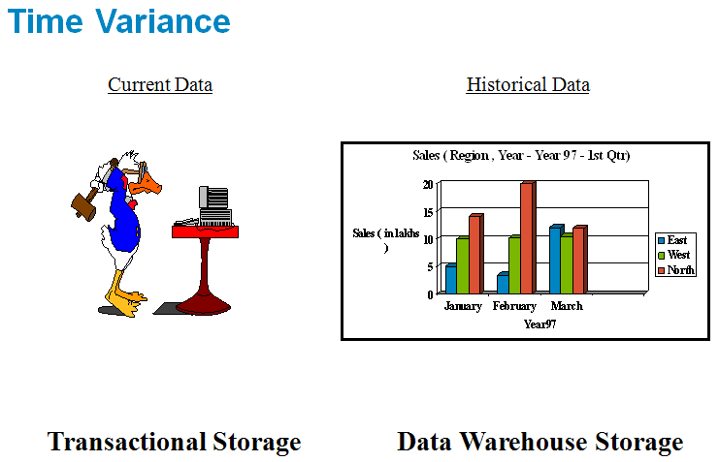
- Non Volatile: Nonvolatile means that, once entered into the warehouse, data should not change. This is logical because the purpose of a warehouse is to enable you to analyze what has occurred. The data that is present in the DWH is Static.
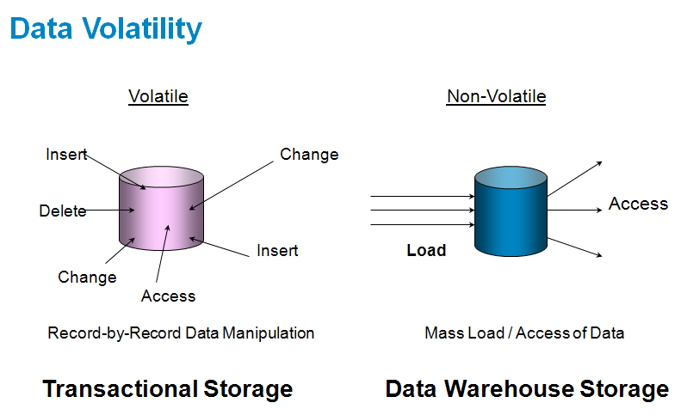
- Integrated: Data warehouses must put data from disparate sources into a consistent format. They must resolve such problems as naming conflicts and inconsistencies among units of measure. When they achieve this, they are said to be integrated.
- Subject Oriented: Data warehouses are designed to help you analyze data. For example, to learn more about your company's sales data, you can build a warehouse that concentrates on sales. Using this warehouse, you can answer questions like "Who was our best customer for this item last year?" This ability to define a data warehouse by subject matter, sales in this case makes the data warehouse subject oriented.

Types of DWH systems: There are mainly 2 types of DWH systems.
- EDW (Enterprise Data Warehouse): It contains the historical business data at the enterprise level to support the business needs of top management in the organization.
- Contains data drawn from multiple operational systems.
- Supports time- series and trend analysis across different business areas.
- Can be used to populate data marts.
- Can be used for everyday and strategic decision making.

- Data Marts: A data mart is a subset of an organizational data store, usually oriented to a specific purpose or major data subject, which may be distributed to support business needs.
- Subset of enterprise data warehouse.
- Organized around a single business process.
- May or may not contain aggregates.
- Less expensive and much smaller than a full blown corporate data warehouse.
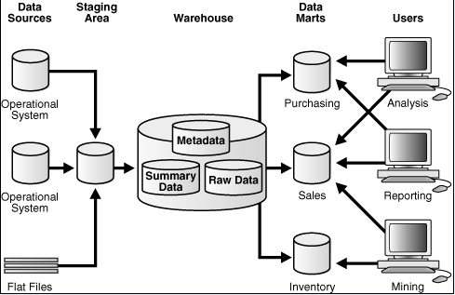
Staging Area:
- A storage area and set of process that clean, transform, combine, removing duplicate, archive and prepare source data for use in data warehouse.
- It accepts data from different sources.
- The structure is closer to the Operational Systems rather than the DW.
- Data arriving at different point of time is merged and then loaded into the DW.
- Usually does not maintain history; only a temporary area.

Data Acquisition:
- Data Acquisition means Extraction, Transformation & Loading.
Here we will extract data from different sources like COBOL, ERP, Operational etc and bring into our Staging Area. Staging Area is a temporary storage area. From Staging Area we will load data into DWH or DM’s.
- Data acquisition process is defined with Data extraction, Data transformation and Data loading.
- Data Extraction: It is a process of reading the data from different sources like Operational sources (OLTP), No SQL databases, Salesforce, Teradata etc.
- Data Transformation: It is a process of transforming data from one format to required business format. In Data transformation we are having 4 types.
- Data Merging: It is a process of integrating the data from similar sources with the similar structure and data type. Ex: Join, Union etc.
- Data Cleansing: It is a process of identifying and changing the inconsistencies and in accuracies. Ex: Initcap, Lower, Upper, NVL etc. Eg: aMit=> Amit
- Data Scrubbing: It is a process of deriving new definitions from existing source definitions. Ex: In target table we will add a new column ‘TAX’, which will be calculated based on the column ‘SAL’ coming from the source.
- Data Aggregation: It is a process of where multiple detail values are summarized into a single summary values typically numeric like Sum, Average, Min, Max etc.

Types of DWH approach:
- Top – Down approach: According to W.H.Inmon, we need to develop the enterprise DWH system and then from the EDW develop subject oriented databases called Datamarts according to the business needs.
- Bottom – Up approach: According to Ralph Kimball, 1st develop the datamarts according to business needs and then integrate all datamarts into EDW.
Types of Data Marts:
- Dependent DM: The DM developed in Top – Down approach is known as Dependent DM. Because 1st we will load data into EDW and then into DM.
- Independent DM: The DM developed in Bottom – Up approach is known as Independent DM. Because 1st we will load data into DM and then into EDW.
- Please find below the example for Dependent Datamart.
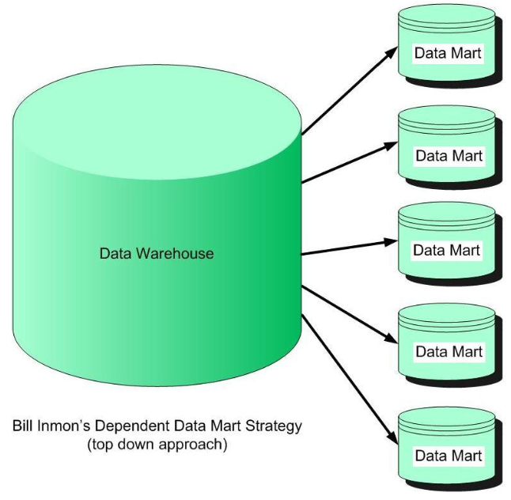

Real Time DWH: Traditionally data warehouses do not contain today's data. They are usually loaded with data from operational systems at most weekly or in some cases nightly, but are in any case a window on the past.
As today's decisions in the business world become more real-time, the systems that support those decisions need to keep up. It is only natural that Data Warehouse, Business Intelligence, Decision Support, and OLAP systems quickly begin to incorporate real-time data. Data warehouses and business intelligence applications are designed to answer exactly the types of questions that users would like to pose against real-time data. Ad-hoc reporting is made easy using today's advanced OLAP tools.

Dimensional Modeling: ERWIN
- A Dimensional modeling is an approach to design the star schema databases.
- A Dimensional modeling approach consists of 3 phases. Conceptual Modeling, Logical Modeling and Physical Modeling.
- A Data modeler needs to understand the following process in steps to implement the star schema design.
Conceptual Modeling:
- A data modeler needs to understand the business requirements clearly.
- Identifying the Grains (The lowest level name in a table), Entities (Tables) and Attributes (Columns).
Logical Modeling:
- Once the grains are identified, design the dimension tables with the lower level grains.
- Once the dimensions are designed, design the fact tables with the key performance indicators.
- Once the dimension and fact tables are designed, establish the relations between Dimensions and Facts using Primary key and Foreign key.
Physical Modeling:
- Move the logical schema structure to the physical database.
Data Warehouse Design:
Dimension table stores attributes, or dimensions, that describe the objects in a fact table (it will have detailed information)
Fact table consists of the measurements, metrics or facts of a business process
Star Schema:
- A star schema is a logical database design which contains a centrally located fact table surrounded by at least one or more dimension tables.
- A Fact table contains composite keys (More than one key) where each candidate key is a foreign key to the dimension table.
- The facts that the data warehouse helps analyze are classified along different dimensions:
- The fact table holds the main data. It includes a large amount of aggregated data, such as price and units sold. There may be multiple fact tables in a star schema.
- Dimension tables, which are usually smaller than fact tables, include the attributes that describe the facts. Often this is a separate table for each dimension. Dimension tables can be joined to the fact table(s) as needed.
- Dimension tables have a simple primary key, while fact tables have a set of foreign keys which make up a compound primary key consisting of a combination of relevant dimension keys.
- Example: Fact.Sales is the fact table and there are three dimension tables Dim.Date, Dim.Store and Dim.Product. Each dimension table has a primary key on its PK column, relating to one of the columns (viewed as rows in the example schema) of the Fact.Sales table's three-column (compound) primary key (Date_FK, Store_FK, Product_FK). The non-primary key [Units Sold] column of the fact table in this example represents a measure or metric that can be used in calculations and analysis. The non-primary key columns of the dimension tables represent additional attributes of the dimensions (such as the Year of the Dim.Date dimension).
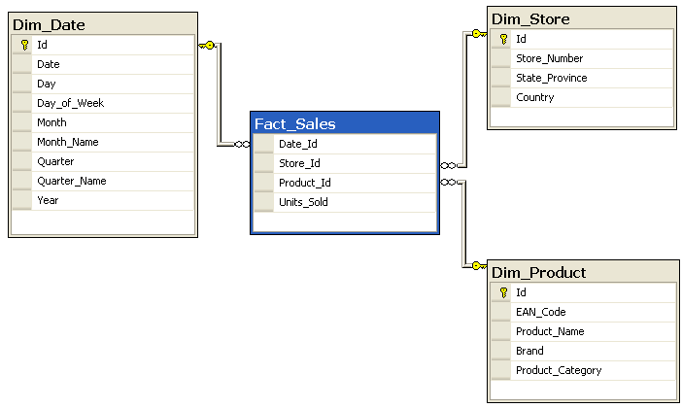
Snow Flake Schema:
- In a Star schema database design, if the dimension table is split into a one or more dimension tables which results in Normalization. Since the database design looks like a snow flake. Hence it is known as Snow flake schema.
- Generally these types of schema designs are not recommended for the warehouse implementations because dimension tables results in Normalization and decrease the performances.
- The snowflake schema is similar to the star schema. However, in the snowflake schema, dimensions are normalized into multiple related tables, whereas the star schema's dimensions are denormalized with each dimension represented by a single table.
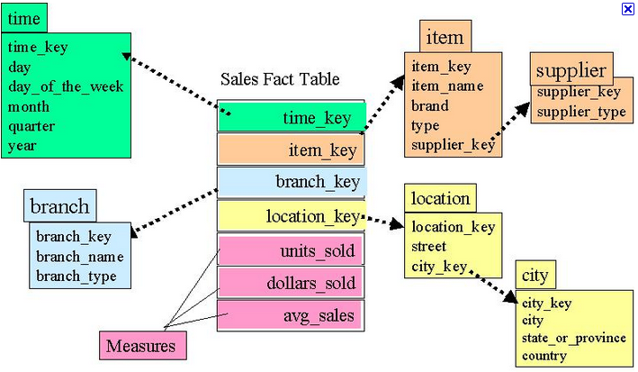

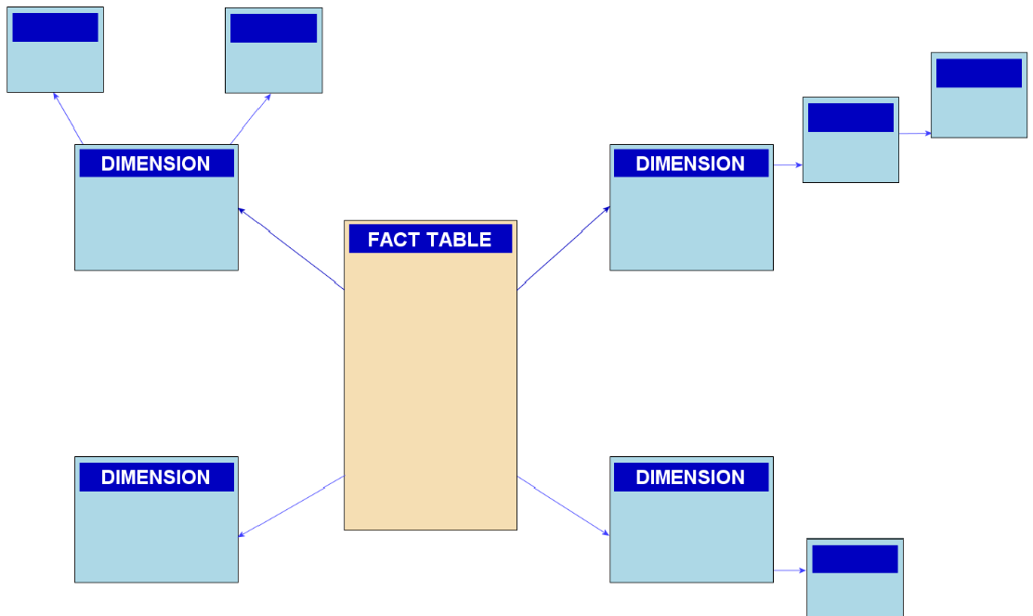

- The advantages and disadvantages of snow flake schema are given below.
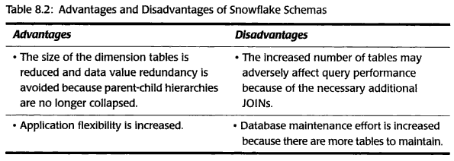
When to go with Star Schema when to go with Snowflake schema design

Whenever your dimension table is growing fast (receiving large volumes of data) then we can normalize that particular dimension table into one more dimension (i.e. one dimension table will be split into one more dimension so inserting data will be faster)

Galaxy Schema or Fact Constellation:
Sophisticated applications may require multiple fact tables to share dimension tables. This kind of schema can be viewed as a collection of stars, and therefore it's called a Galaxy Schema or a Fact Constellation. As we see in the two star schemas as above, the two fact tables, sales table and purchase table are now sharing both the 'product' and 'time' dimension tables. Therefore we decide to choose Galaxy Schema as the model for our data warehouse, which is displayed as follows
Before applying Galaxy schema:
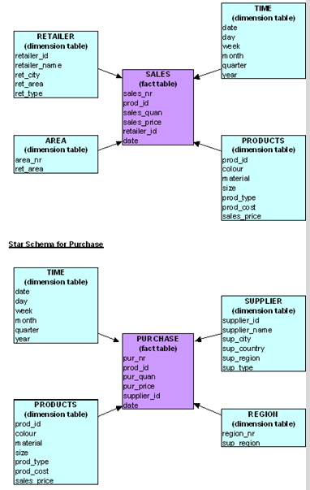
After applying Galaxy schema:
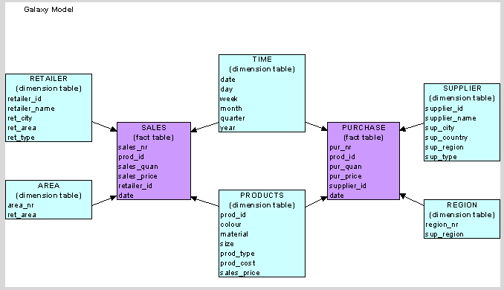
Fact Tables:
- A fact table contains composite keys (More than one key) where each candidate key is a foreign key to the dimension table.
- A fact table contains facts. In DWH, facts are generally numeric.
- A measure is a numeric attribute of a fact, representing the performance or behavior of the business relative to dimensions.
- A fact table contains the fact information at the lowest level granularity.
- The level at which fact information stores in a fact table is called as Fact Granularity or Grain of fact.
- A fact table can contain fact information either in 1NF or 2NF or 3NF. (NF: Normalization Form).
- To provide the meaningful business context to the facts design the dimension tables with a de-normalized business information.

Types of Fact Tables:
- Additive Fact table:
- A fact which can be summed up for any of the dimensions available in the fact table is called as Additive fact.

Example: Sales Amount by Store by Product in a given day is an additive fact as it can be summed up across all STORE, PRODUCT and TIME dimensions. We can sum the Sales for a week to get the Total Sales Amount for that week.

- Semi Additive Fact table:
- A fact which can be summed up for few dimensions but not for all the dimensions present in the fact table.
Example: Current Balance for an Account is the Semi-Additive fact as it can be summed up for all Accounts to find out the Total current balance of the Bank. It won’t make sense to sum up the Current Balance for an Account in a given month (Time).

- Non Additive Fact table:
- A fact which cannot be summed up for any of the dimensions available in the fact table.
Example: AVERAGE.

- Fact less Fact Table:
- A fact which contains only Keys but not measures.

Example 1:
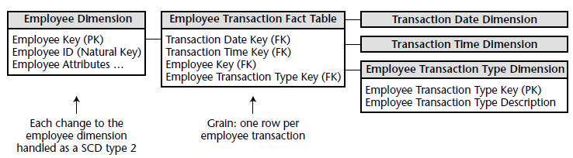
Example 2:
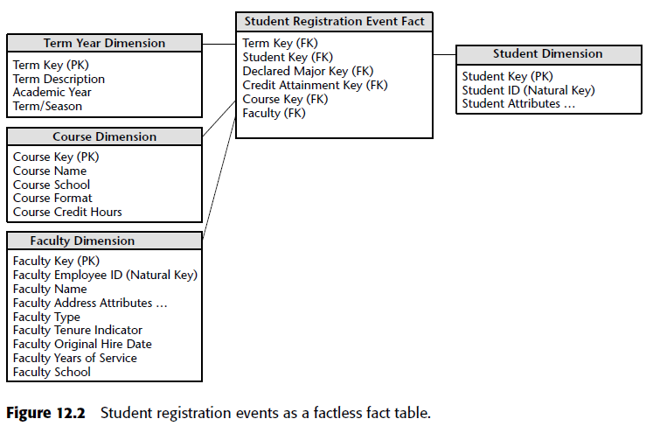

Types of Facts:
- Accumulative Fact Table:
- Generally these fact tables describe what has happened over the period of time. A cumulative fact table contains Additive or Semi additive facts. Ex: Transactional fact table, Orders fact table.
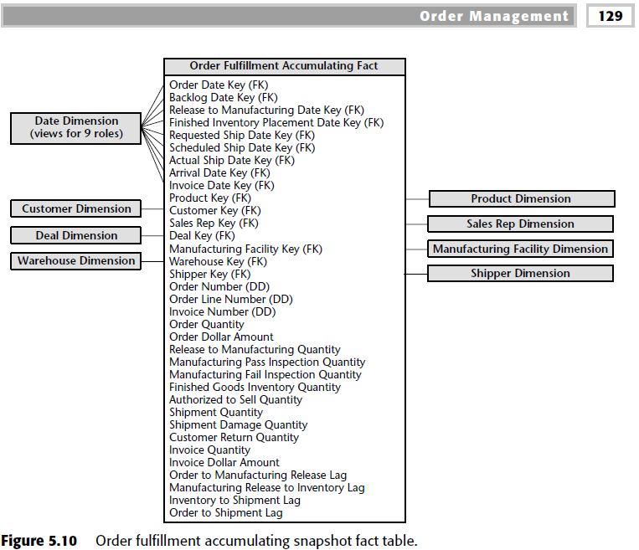
- Snap shot Fact Table:
- This type of fact table describes the status of things at a particular instant of the time.
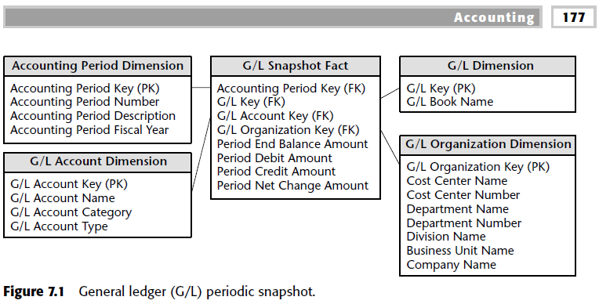

Dimension Tables:
- The dimension tables contain attributes (or fields) used to constrain and group data when performing data warehousing queries.
- In a data warehouse, a dimension is a data element that categorizes each item in a data set into non-overlapping regions.
- For example, "Customer", "Date", and "Product" are all dimensions that could be applied meaningfully to a sales receipt.

Types of Dimensions Tables:
- Conformed Dimension: The dimension that is shared across multiple fact tables. At the most basic level, conformed dimensions mean the exact same thing with every possible fact table to which they are joined. The date dimension table connected to the sales facts is identical to the date dimension connected to the inventory facts. Ex: Time Dimension, Geographical Dimension.
- Junk Dimension: Junk dimension is just a dimension that stores unwanted attributes. A junk dimension is a convenient grouping of typically low-cardinality flags and indicators. By creating an abstract dimension, these flags and indicators are removed from the fact table while placing them into a useful dimensional framework. Ex:
Source |  |  | Junk Dimension
FLAG_1 | Yes/No |  | Key_ID | Flag_1 | Flag_2
FLAG_2 | True/False |  | 1 | Yes | TRUE
 |  |  | 2 | Yes | FALSE
 |  |  | 3 | No | TRUE
 |  |  | 4 | No | FALSE

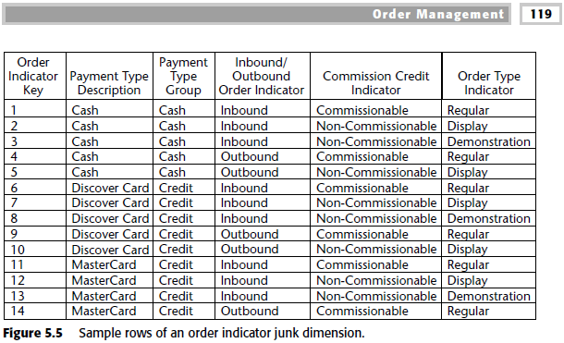
- Degenerated Dimension: In a data warehouse, a degenerate dimension is a dimension which is derived from the fact table and doesn't have its own dimension table. The decision to use degenerate dimensions is often based on the desire to provide a direct reference back to a transactional system without the overhead of maintaining a separate dimension table. A dimension key, such as a transaction number, invoice number, ticket number, or bill-of-lading number, that has no attributes and hence does not join to an actual dimension table. Degenerate dimensions are very common when the grain of a fact table represents a single transaction item or line item because the degenerate dimension represents the unique identifier of the parent.
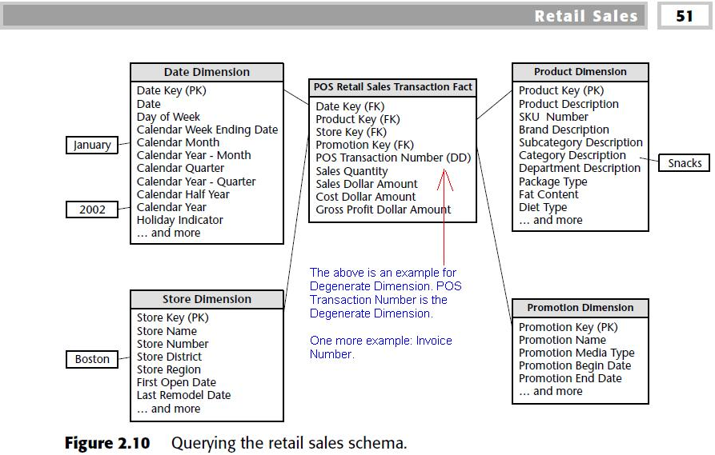

- Slowly Changing Dimension: Slowly Changing Dimensions (SCDs) are dimensions that have data that changes slowly, rather than changing on a time-based, regular schedule. It’s further classified into 3 types.
- SCD Type 1: This type of dimension table maintains the latest or current data.
- SCD Type 2: This type of dimension table maintains complete history.
- SCD Type 3: This type of dimension table maintains partial history.
- Monster Dimension: The dimension that contains > 100 million records.
Example: Customer Dimension.
- Casual Dimension: In most data warehouses, you build a fact table record when something happens. These dimensions, such as promotion, contract, deal, store condition, or even weather, provide additional insight into the cause of an event.
Example 1: i) At a bank ATM, a fact table record is created for every customer transaction. The dimensions of this fact table record are financial service, ATM location, customer, transaction type, and time.
Here a physical event takes place, and the data warehouse responds by storing a fact table record. Each event represents a conscious decision by the customer to use the product or the service. A good marketing person is fascinated by these events. We call a dimension like this a "causal" dimension, because it explains what caused the event.
At a bank ATM, there may be a New Account Drive, a Promotional Mailing, or a Branch Teller Surcharge. Again, each of these management decisions affects the volume and the patterns of ATM usage. There may also be exogenous effects on ATM usage, such as a national holiday or bad weather, which are not the result of a human management decision. Consider causal dimensions when you want your data warehouse to be more informative.
Example 2: When the cash register rings in a retail store, a fact table record is created for each line item on the sales ticket. The obvious dimensions of this fact table record are product, store, customer, sales ticket, and time, as shown in Figure 1.
In the below image, I showed how to add a sixth "causal" dimension that explains why the sales took place, as shown in Figure 2.

Figure 1:
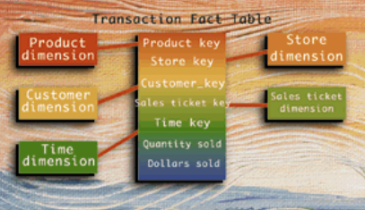

The new causal key is simply inserted into the existing fact table without violating the grain of the fact table or changing any existing applications. A causal dimension is a kind of advisory dimension that should not change the fundamental grain of a fact table.

Figure 2:
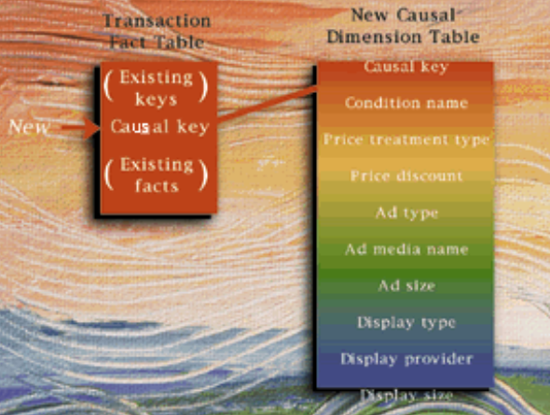

Data Warehouse (OLAP) | Operational Database(OLTP)
It involves historical processing of information. | It involves day-to-day processing.
OLAP systems are used by knowledge workers such as executives, managers, and analysts. | OLTP systems are used by clerks, DBAs, or database professionals.
It is used to analyze the business. | It is used to run the business.
It focuses on Information out. | It focuses on Data in.
It is based on Star Schema, Snowflake Schema, and Fact Constellation Schema. | It is based on Entity Relationship Model.
It focuses on Information out. | It is application oriented.
It contains historical data. | It contains current data.
It provides summarized and consolidated data. | It provides primitive and highly detailed data.
It provides summarized and multidimensional view of data. | It provides detailed and flat relational view of data.
The number of users is in hundreds. | The number of users is in thousands.
The number of records accessed is in millions. | The number of records accessed is in tens.
The database size is from 100GB to 100 TB. | The database size is from 100 MB to 100 GB.
These are highly flexible. | It provides high performance.

Below are the differences between systems.
. OLTP OLAP
1. It is dynamic. 1. It is static [unchanged].
2. It follows normalization. 2. It follows denormalization.
3. It contains current data. 3. It contains historical data.
4. It is designed to support transactional 4. It is designed to support decision making process. Process.
5. It contains detailed data. 5. It contains summarized information.

ODS DWH
1. It is designed to support operational 1. It is designed to support decision making process. Process.
Similarities:-
2. Integrated database. 2. Integrated database.
3. Enterprise data. 3. Enterprise data.
4. Subject oriented database. 4. Subject oriented database.
Differences:-
5. Contains current information. 5. Contains historical information.
6. Data is volatile. 6. Data is non-volatile.
7. Contains detail information. 7. Contains summary information.

ODS OLTP
1. Subject oriented database. 1. Application oriented database.

OLTP DWH
1. Data is volatile. 1. Data is non-volatile.
2. It contains current data. 2. It contains historical data.
3. It is application oriented database. 3. It is subject oriented database.
4. It is not flexible. 4. It is flexible.
5. It stored all data. 5. It stores relevant data.

OLTP DSS
1. It is designed to support operational 1. It is designed to support decision making process. Process.
2. Data is volatile. 2. Data is non-volatile.
3. Data is in inconsistency form. 3. It is in consistent form.
4. It stores recent data for approximately 4. It stores One year data.
4 to 6 months data.
5. It follows normalized schema. 5. It follows star schema.

DWH DM
1. It is about entire organization. 1. It is about individual department in the organization.
2. It is created on RDBMS. 2. It is created on RDBMS & MDDB.
3. It follows integrated schema design. 3. It follows star schema design.
4. It is integrated database. 4. Subject oriented databases.

TERMINOLOGIES USED IN DATA WAREHOUSE:
i) Candidate Key : An attribute of the table that will uniquely identify every tuple of the table is called as candidate key. A table can contain more than one candidate key. Among all available candidate keys, the candidate key used by the user to identify the tuples uniquely is called as primary key. For example, if we take the Department table that contains Deptno, Dname and Location Columns, both Deptno and Dname Columns are candidate keys. But as we use Deptno to uniquely identify the rows of department table, Deptno is called as primary key.
ii) Secondary Key : An attribute that is used to uniquely identify the rows of the table when primary key fails is called as secondary key. For example, when we have to retrieve marks of a student, we will provide student’s hall ticket no. Here hall ticket no is primary key. If user lost his hall ticket no., then we can use student name and his father name combination to retrieve marks. Hence combination of these two columns is called as secondary key.
Natural Key:
Single or set of columns that uniquely identify a record in a table, where key columns are made up of real data. Typically string
Advantages of using natural Key:
Will require no joins when you only need to return the key attribute of a foreign key table as natural key will already be imbedded in your table.
Easier to search because natural keys have meaning and will be stored in your table.
Surrogate Key:
IDENTITY COLUMN generated on top of single column or set of columns that uniquely identifies record in a table, it will not have any Business Meaning. Typically integer, require 4 bytes to store, so the primary key index structure will be smaller in size
Advantages of using Surrogate Key:
If your business rules change, easy to change key attributes even though foreign relationships have been built
Primary key index will be smaller for Surrogate keys as they are typically smaller in size and are integers instead of strings, so joins between two tables will take less time

